**GLUT Installation**

**GLUT overview**

GLUT (Graphics Library Utility Toolkit) must be properly installed before using the C++ Graphics Library (**graph1.lib**) used in this course. GLUT is responsible for displaying the core graphics used by **graph1.lib. GLUT is already installed on the UCA computers - you only need to perform this installation on the PCs that you own.**

**Note:** GLUT and the C++ Graphics Library can only be installed on computers running the Windows OS.

**GLUT Installation**

Perform the following steps to install GLUT on you PCs.

1. Download *glut.zip* from blackboard.

2. Extract all files from glut.zip. You should see the following files:

*glut.def* Export Definition File (informational file)

*glut.h* Header file

*glut.dll* Dynamic Library file

*glut32.lib* Static Library file

*README-win32.txt* Version/Compilation File (informational file)

3. Locate the *top* level directory where .Net 2013 is installed. For a typical installation this top level path would be located at:

C:\Program Files\Microsoft Visual Studio 12.0\VC

4. Locate the *include* folder beneath this top level path. For a typical installation, this folder would be located at:

C:\Program Files\Microsoft Visual Studio 12.0\VC\include

5. Create a new folder **inside** of the *include* folder. Name this new folder *gl*. Your *include* folder should now appear as shown below:

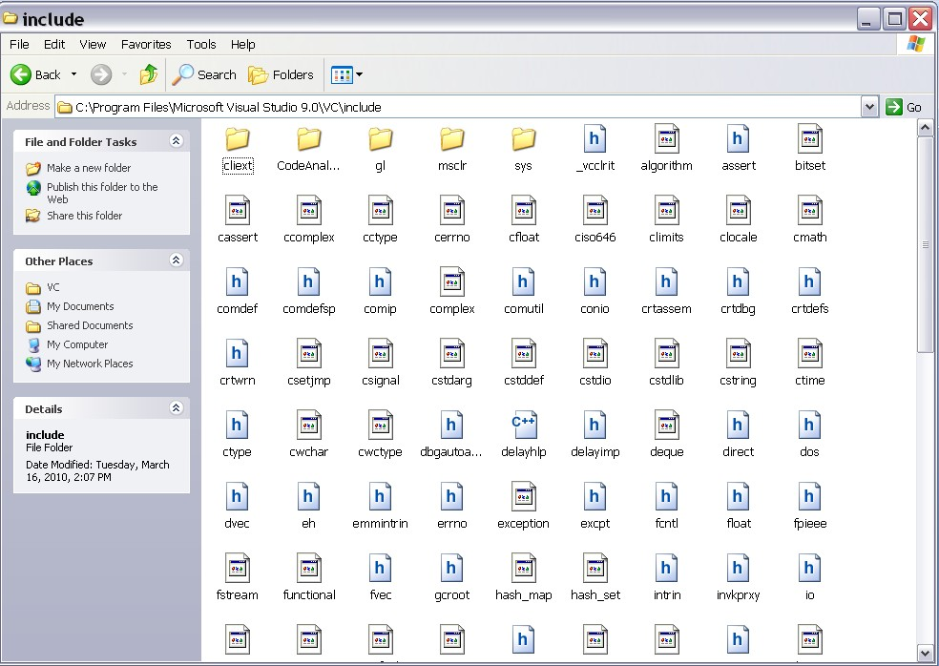

**Fig. 1. Creation of *gl* folder**

6. Copy the following file **into** the *gl* folder:

*glut.h*

7. Locate the *lib* folder beneath the top level path. For a typical installation, this folder is located at:

C:\Program Files\Microsoft Visual Studio 12.0\VC\lib

8. Copy the following file **into** the *lib* folder:

*glut32.lib*

9. Locate the *system* folder for Windows. For a typical installation under Windows XP, this folder is located at:

C:\WINDOWS\system

**(This folder may be named differently or located in a different folder for other versions of Windows)**

10. Copy the following file **into** the *system* folder:

*glut32.dll*

11. Reboot your computer

12. Create MSVC++ projects as outlined in **VisualStudioTutorial.pdf.**